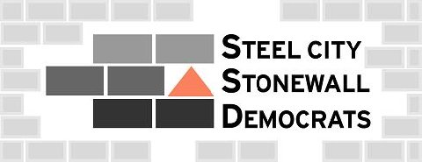
VOTE NOVEMBER 3rd 2009!!! It is critical that progressive people get out and vote this year. Statewide Judicial races will dominate this year’s elections. We all have seen in California, Massachusetts, & Vermont how state courts play a critical role in upholding the constitutional rights of LGBT people to receive equal treatment under the law. The candidates who ultimately win on November 3rd 2009 will shape Pennsylvania for the next decade!!!

Steel-City Stonewall Democrats Endorsements for the November 3rd 2009 General Election.

Pennsylvania Supreme Court: Jack A. Panella

(Jack Panella will be opposed in the November 3rd, 2009 General Election by Joan Orie Melvin. Joan Orie Melvin is the sister of State Senator Jane Orie who is a leader of anti-equality efforts in the Pennsylvania Senate.)

Pennsylvania Superior Court: Robert Colville, Anne Lazarus, Kevin McCarthy & Teresa Sarmina

Pennsylvania Commonwealth Court: Barbara Behrend Ernsberger & Linda S. Judson

(ALL of the above judicial candidates will face HARD-RIGHT social conservatives in this year’s General Election.)

Allegheny Court of Common Pleas: Susan DiLucente, Arnie Klein, Don Walko, & Joe Williams

Allegheny County Sherriff - Bill Mullen

Allegheny County Council District 1: Thomas R. Michalow

(Thomas Michalow is challenging incumbent Matt Drozd. Matt Drozd is one of the Allegheny County Council Members who voted against the Allegheny County Non-Discrimination Ordinance. Thomas Michalow supports the Ordinance & has taken outstanding positions on LGBT issues. You can find more info at http://tommichalow.com)

Allegheny County Council District 3: Jim Burn

Allegheny County Council District 13: Amanda Green

Pittsburgh City Council District 4: Natalia Rudiak

Pittsburgh City Council District 8: Bill Peduto

ALL of the above candidates have filled out & signed questionnaires detailing their beliefs & support for LGBT equality. You can read their completed questionnaires in the news archive of our web page: www.steel-city.org.

