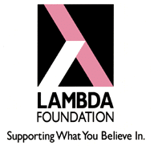

THE LAMBDA FOUNDATION & THE GLCC

WOULD LIKE YOU TO JOIN THEM FOR OUR FIRST FAMILY PICNIC

WHERE: NORTH PARK GOLD STAR GROVE

WHEN: SUNDAY, AUGUST 9, 2009 12:00 TO 6:00PM

FISHING CONTEST AND GAMES FOR THE KIDS

PRIZES AND PLENTY OF FOOD

PETS WELCOME

TICKETS $20 PER FAMILY
$10 SINGLES

PLEASE CALL 412-521-5444 FOR TICKETS.

The Lambda Foundation ● PO Box 5169 ● Pittsburgh PA 15206-0169 ● 412-521-5444 ● www.lambda-pgh.org

